Project Design Phase
Solution Architecture

Date | 23 June 2026
Team ID
Project Name | Darshan Ease
Maximum Marks | 4 Marks

Solution Architecture:
Solution architecture is a complex process – with many sub-processes – that bridges the gap between business problems and technology solutions. Its goals are to:
- Find the best tech solution to solve existing business problems.
- Describe the structure, characteristics, behavior, and other aspects of the software to project stakeholders.
- Define features, development phases, and solution requirements.
- Provide specifications according to which the solution is defined, managed, and delivered.

Darshan Ease - Solution Architecture Diagram:

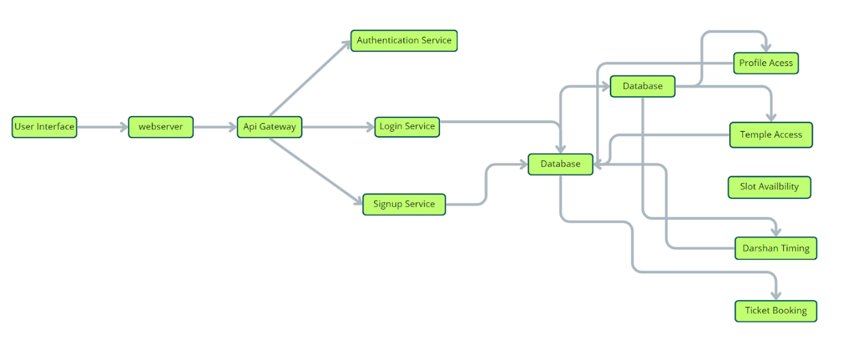
Figure 1: Technical architecture of the Darshan Ease temple darshan booking application
Key Components: User Interface (separate dashboards for Devotees, Organizers and Admin), Web Server (hosts frontend and backend services), Authentication Service (secure login and role-based authentication), Temple Service, Event Service, Slot Management Service, Booking Service, Admin Service, and a Database that stores users, temples, bookings, events and slots.

